Data Analyst
Co-Living Operations — Data Audit & Insight
Tool: Excel or Google Sheets (mandatory) |

What We're Testing | Your Tools | What to Submit
Data cleaning, analytical thinking, pattern spotting, and communicating insight clearly | Excel or Google Sheets — mandatory. Charts / pivot tables expected. | 1 workbook with one tab per task + written answers filled into this doc

👋 Before you start: We care more about HOW you think than whether every number is perfect. Write your assumptions down. If you spot something we didn't ask about, flag it anyway. That's what a good analyst does.

The Situation

You've just been brought in as a Data Analyst at NestSpace, a co-living company with 120 beds across 4 properties. It's Monday morning. Your Operations Manager drops a message:

"We just lost a property audit last week because our data was all over the place — wrong move-in dates, missing deposits, people who've left still showing as active. I need you to go through last quarter's resident data, clean it up, figure out where we're bleeding revenue, and tell me which properties need my attention first. I need something on my desk by EOD."

You've been handed three raw data exports. There are four tasks. Work through them in order — each task builds on the one before it.

The Raw Data (copy each table into a separate sheet tab)

Data contains formatting issues, logical errors, missing values, and inconsistencies.

Table A — Resident Master List (Tab name: RESIDENTS)

ID | Resident Name | Property | Bed Code | Move-In Date | Move-Out Date | Status | Monthly Rent (₹) | Deposit Paid | Deposit Amt (₹) | Notice Given
R01 | Ananya Roy | Koramangala | K-101 | 01/01/2025 | 31/03/2025 | Moved Out | 12,000 | Yes | 24,000 | Yes
R02 | RAHUL MEHTA | Whitefield | W-204 | 15/01/2025 |  | Active | 9,500 | Yes | 19,000 | No
R03 | priya nair | Koramangala | K-101 | 10/01/2025 ← Same bed as R01, dates overlap | 30/04/2025 | Active | 12,000 | No | 0 | No
R04 | Vikram Sinha | HSR Layout | H-302 | 01/02/2025 | 28/02/2025 | Active ← Move-out date has passed | 11,000 | Yes | 22,000 | Yes
R05 | fatima sheikh | Whitefield | W-107 | 20/02/2025 |  | Active | 7,500 ← Below min ₹8,000 | Yes | 15,000 | No
R06 | Arun Pillai | Indiranagar | I-210 | 01/03/2025 |  | Active | 10,500 | No | 0 | No
R07 | Meena Iyer | HSR Layout | H-108 | 05/03/2025 |  | Active | 11,000 | Yes | 22,000 | No
R08 | Dev Shah | Koramangala | K-205 | 10/03/2025 | 05/03/2025 | Moved Out ← Move-out before move-in | 12,000 | Yes | 24,000 | Yes
R09 | Zara Khan | Indiranagar | I-210 | 15/03/2025 |  | Active ← Same bed as R06, no end date on R06 | 10,500 | Yes | 21,000 | No
R10 | Nikhil Gupta | Whitefield | W-310 | 01/04/2025 |  | Active | 9,500 | No | 0 | No
R11 | Leela Thomas | HSR Layout | H-215 | 01/04/2025 |  | Active | 11,000 | Yes | 11,000 | No ← Deposit amount = 1 month only, should be 2
R12 | Sanjay Tiwari | Koramangala | K-308 | 15/04/2025 |  | Active | 12,000 | Yes | 24,000 | No
R13 | kavya reddy | Indiranagar | I-114 | 01/05/2025 |  | Active | 10,500 | Yes | 21,000 | No
R14 | Omar Sheikh | Whitefield | W-204 | 10/05/2025 |  | Active ← Same bed as R02, no end date on R02 | 9,500 | No | 0 | No
R15 | Tanvi Desai | HSR Layout | H-302 | 01/06/2025 |  | Active | 11,000 | Yes | 22,000 | No

📌 Policy Reminders: Min. rent: ₹8,000/month for all properties. Security deposit = 2 months’ rent. Status must be updated within 3 days of move-out. Bed cannot be assigned to two Active residents simultaneously.

Table B — Rent Payment Log (Tab name: PAYMENTS)

Payment ID | Resident ID | Month | Amount Due (₹) | Amount Paid (₹) | Payment Date | Mode | Status
P001 | R01 | January 2025 | 12,000 | 12,000 | 03/01/2025 | UPI | Cleared
P002 | R02 | January 2025 | 9,500 | 9,500 | 05/01/2025 | Bank Transfer | Cleared
P003 | R03 | January 2025 | 12,000 | 6,000 | 10/01/2025 | Cash | Partial ← Only half paid
P004 | R04 | February 2025 | 11,000 | 0 |  |  | Unpaid
P005 | R05 | February 2025 | 7,500 | 7,500 | 02/02/2025 | UPI | Cleared
P006 | R06 | March 2025 | 10,500 | 10,500 | 01/03/2025 | UPI | Cleared
P007 | R07 | March 2025 | 11,000 | 11,000 | 04/03/2025 | Bank Transfer | Cleared
P008 | R02 | February 2025 | 9,500 | 9,500 | 07/02/2025 | UPI | Cleared
P009 | R08 | March 2025 | 12,000 | 12,000 | 10/03/2025 | Cash | Cleared
P010 | R09 | March 2025 | 10,500 | 0 |  |  | Unpaid
P011 | R10 | April 2025 | 9,500 | 9,500 | 02/04/2025 | UPI | Cleared
P012 | R11 | April 2025 | 11,000 | 11,000 | 05/04/2025 | Bank Transfer | Cleared
P013 | R12 | April 2025 | 12,000 | 12,000 | 03/04/2025 | UPI | Cleared
P014 | R05 | March 2025 | 7,500 | 7,500 | 03/03/2025 | UPI | Cleared
P015 | R13 | May 2025 | 10,500 | 0 |  |  | Unpaid
P016 | R06 | April 2025 | 10,500 | 5,000 | 08/04/2025 | Cash | Partial ← Only half paid
P017 | R14 | May 2025 | 9,500 | 9,500 | 04/05/2025 | UPI | Cleared
P018 | R15 | June 2025 | 11,000 | 0 |  |  | Unpaid
P019 | R03 | February 2025 | 12,000 | 12,000 | 06/02/2025 | UPI | Cleared
P020 | R04 | March 2025 | 11,000 | 11,000 | 05/03/2025 | Bank Transfer | Cleared

Table C — Maintenance Tickets (Tab name: TICKETS)

Ticket ID | Property | Bed / Area | Issue | Priority | Raised On | Resolved On | Status | Raised By
T01 | Koramangala | K-101 | Water leakage from ceiling | High | 02/03/2025 | 10/03/2025 | Resolved | Ananya Roy
T02 | Whitefield | Common | Wi-Fi router not working | Medium | 15/03/2025 |  | Open | Rahul Mehta
T03 | HSR Layout | H-302 | Broken wardrobe door | Low | 20/03/2025 |  | Open | Vikram Sinha
T04 | Indiranagar | I-210 | AC not cooling | High | 01/04/2025 | 03/04/2025 | Resolved | Arun Pillai
T05 | Koramangala | K-205 | Bathroom flush broken | High | 05/04/2025 |  | Open | Dev Shah
T06 | Whitefield | W-107 | Mould on bathroom wall | Critical | 10/04/2025 |  | Open | Fatima Sheikh
T07 | HSR Layout | Common | Hot water not available | High | 15/04/2025 | 18/04/2025 | Resolved | Meena Iyer
T08 | Indiranagar | I-114 | Main door lock faulty | Critical | 01/05/2025 |  | Open | Kavya Reddy
T09 | Koramangala | K-308 | Electricity tripping | High | 10/05/2025 |  | Open | Sanjay Tiwari
T10 | Whitefield | W-310 | Geyser not working | Medium | 12/05/2025 | 20/05/2025 | Resolved | Nikhil Gupta
T11 | HSR Layout | H-215 | Pest infestation in kitchen | High | 20/05/2025 |  | Open | Leela Thomas
T12 | Indiranagar | Common | CCTV camera offline | Medium | 25/05/2025 |  | Open | Zara Khan
T13 | Koramangala | K-101 | Seepage from window | Medium | 01/06/2025 |  | Open | Priya Nair
T14 | Whitefield | W-204 | Cupboard key missing | Low | 05/06/2025 | 07/06/2025 | Resolved | Omar Sheikh
T15 | HSR Layout | H-108 | Light fitting loose | Low | 10/06/2025 |  | Open | Dev Shah

Task 1 — Clean the Data

Start with Table A (RESIDENTS tab). There are 8 data issues hidden across the three tables — some are hard errors, some are logical inconsistencies that require you to think, not just look. Find them, fix them, and fill in the Error Log below.

💡 Tip: An error isn't always a typo. Ask yourself: does this make sense operationally? A resident marked Active whose move-out date was 3 months ago is just as much of a problem as a wrong date format.

Your Answer — Error Log
Create a tab called ERROR_LOG in your workbook and fill in this table. Also fill it here:

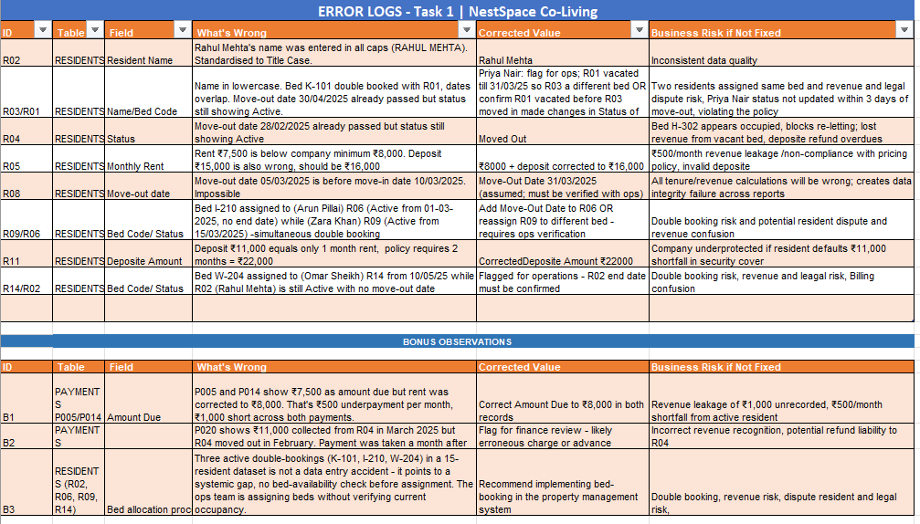

Bonus Question
Besides the 8 errors above, did you notice anything else in the data that a good analyst should flag? List up to 2 additional observations
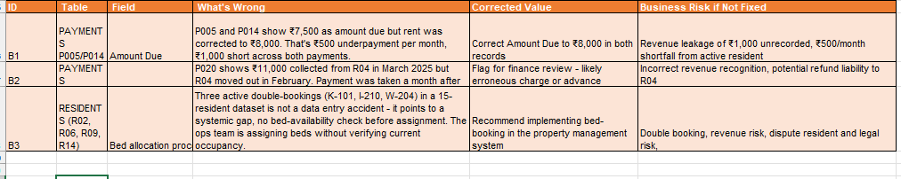

2 — Revenue & Dues Analysis

Now that the data is clean, your manager wants to understand the money situation. Use your cleaned RESIDENTS and PAYMENTS tabs to answer the following. Show your working in the spreadsheet — no hard-coded answers.

2A — Outstanding Dues
Calculate the total rent outstanding (Unpaid + Partial) for each property. Then answer:

- Which property has the highest total outstanding rent? By how much does it lead the second-highest?

Indiranagar has the highest outstanding rent at ₹26,500 - three residents haven't fully paid (R09, R13, and R06 partial). HSR Layout is second at ₹22,000. Gap between the two is ₹4,500.

- There are 2 residents who have made partial payments. What is the total shortfall from those two payments combined?

Two residents made partial payments - R03 paid ₹6,000 against ₹12,000 due (shortfall ₹6,000), and R06 paid ₹5,000 against ₹10,500 due (shortfall ₹5,500). Total shortfall from both = ₹11,500.

- One resident's rent is below the company minimum. If their rent is corrected to ₹8,000 going forward, how much extra monthly revenue does that generate across a 3-month period?

R05 Fatima Sheikh's rent was below the minimum at ₹7,500. Correcting it to ₹8,000 gives ₹500 extra per month - over 3 months that's ₹1,500 additional revenue.

2B — Deposit Health Check
Using the RESIDENTS tab, calculate:

- How many residents have NOT paid their deposit? List their names and the total deposit amount outstanding (use the correct 2-month policy amount for each).

4 residents haven't paid any deposit - Priya Nair, Arun Pillai, Nikhil Gupta, and Omar Sheikh - totalling ₹83,000. R11 Leela Thomas paid only ₹11,000 instead of ₹22,000. Total deposit gap across all five residents = ₹94,000.

- How many residents have paid a deposit that is LESS than the 2-month policy amount? What is the total gap?

R11 Leela Thomas is the only resident who paid a deposit but came up short she paid ₹11,000 against the required ₹22,000, leaving an ₹11,000 gap. All other residents who paid deposit either met the policy amount exactly or had their deposit corrected.

2C — Your Summary Table
Create a summary table in your spreadsheet (Tab name: REVENUE_SUMMARY) with one row per property showing: Total Beds, Active Residents, Total Monthly Rent Collectible, Total Rent Collected, Total Outstanding, and Total Deposit Gap. Paste a screenshot or share the link below:

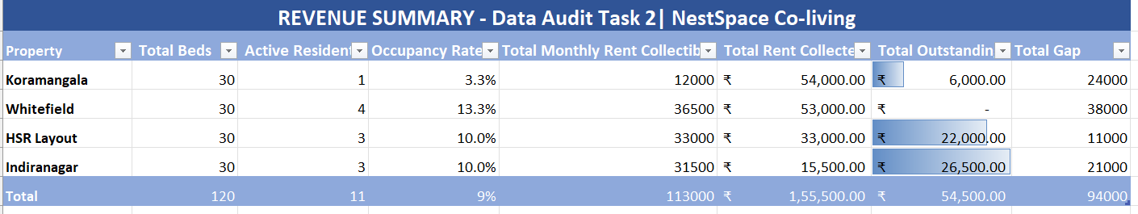

3 — Maintenance Ticket Aging

Use the TICKETS tab. Assume today is 20 June 2025. For every OPEN ticket, calculate how many days it has been unresolved. Then classify each into an aging bucket and answer the questions below.

Aging Buckets
Days Open | Label | What It Signals
0 – 7 days | On Track | Being handled within SLA
8 – 14 days | Needs Follow-Up | PM should check in today
15 – 30 days | Overdue | Escalate to Operations Manager
31+ days | Critical | Immediate action — resident at risk of leaving

Add two columns to your TICKETS tab: 'Days Open' and 'Aging Bucket'. Use a formula for both. Apply conditional formatting: Red = Critical, Orange = Overdue, Yellow = Needs Follow-Up, Green = On Track.

Your Answers

- Which property has the most Critical or Overdue open tickets? How many?

Koramangala has the most with 3 Critical/Overdue tickets - bathroom flush broken (T05, 76 days), electricity tripping (T09, 41 days), and seepage (T13, 19 days). All other properties have 2 each. Worth noting Whitefield has the oldest single ticket in the system - Wi-Fi down for 97 days.

- There are two Critical-priority tickets that have been open for over 30 days. What is the resident risk for each, and what would you recommend?

T06 Whitefield - mould on bathroom wall, 71 days. This is a health hazard and a legal liability, needs a contractor today. T08 Indiranagar - main door lock broken, 50 days. A resident can't secure her own room, that's a direct safety risk. Both should have been actioned weeks ago.

- Write a 4-sentence escalation message to your operations Manager about the maintenance situation. Be specific — name the properties, ticket IDs, and recommended actions.

1.For site visits this week, I'd suggest starting with Whitefield. The Wi-Fi has been down for 97 days which is frankly embarrassing, the mould needs a physical check beyond just the contractor fix, and there's a bed conflict on W-204 that we need to sort out in person. A lot to fix but one visit covers it all.
2.Indiranagar should be your second stop. Beyond the door lock, we have ₹26,500 in outstanding rent across three residents - that's not a coincidence, something's going on there that a phone call won't fix.
3.Koramangala has the most open tickets right now (3), including electrical tripping which I wouldn't sit on much longer. Aim to get there by end of week.

4. HSR Layout is relatively stable but no outstanding rent but pest infestation in the kitchen (T11) and a wardrobe that's been broken since March (T03) need to get scheduled before residents start complaining more formally.

Task 4 — Property Health Dashboard [10 Marks]

Your manager needs a single tab that tells the full story in under 60 seconds. Create a tab called DASHBOARD. It should cover all four properties and answer the six questions below using your cleaned and analysed data. No raw data on this tab — summaries only.

The 6 Questions Your Dashboard Must Answer
# | Question | Data Source
1 | What is the occupancy rate for each property? (Active residents ÷ total beds per property) | Occupancy rate  1.Koramangala 3.3% (1/30)  2. Whitefield 13.3% (4/30  3. HSR Layout 10% (3/30)  4. Indiranagar 10% (3/30).  Overall occupancy is  9.2% (11/120) well below capacity across all four properties.
2 | Which property has the highest total outstanding rent? | Highest outstanding rent Indiranagar has the most outstanding at ₹26,500  two residents haven't paid at all (R09 and R13, ₹10,500 each) and R06 made only a partial payment leaving a ₹5,500 shortfall.  HSR Layout is second at ₹22,000.
3 | Which property has the most overdue or critical maintenance tickets? | Most overdue/critical tickets Koramangala has the most with 3 Critical or Overdue tickets flush broken for 76 days, electricity tripping for 41 days, and seepage for 19 days.  Every other property has 2 each.
4 | How many residents across all properties have not paid their deposit? | Residents without deposit  Four residents haven't paid any deposit  Priya Nair (₹24,000),  Arun Pillai (₹21,000),  Nikhil Gupta (₹19,000), and  Omar Sheikh (₹19,000). That's ₹83,000 sitting uncollected.  On top of that, Leela Thomas paid only ₹11,000 against a required ₹22,000 another ₹11,000 gap. Total deposit gap across all five residents = ₹94,000.
5 | What is the overall rent collection rate? | 74% collection rate.  We collected ₹1,55,500 against ₹54,500 still outstanding.
6 | Which single property needs the most attention right now — and why? | Whitefield, and it's not close.  Mould on the bathroom wall ignored for 71 days that's a health hazard and a legal liability.  Wi-Fi down for 97 days, the oldest unresolved ticket across all four properties.  Two residents assigned to the same bed with no resolution in sight. And the highest deposit gap at ₹38,000.  Every other property has one or two problems. Whitefield has all of them at once. Visit this week.

⭐ Bonus: Add charts of your choice that visualises a meaningful insight from the data.

Your Answer — Dashboard Screenshot or Link
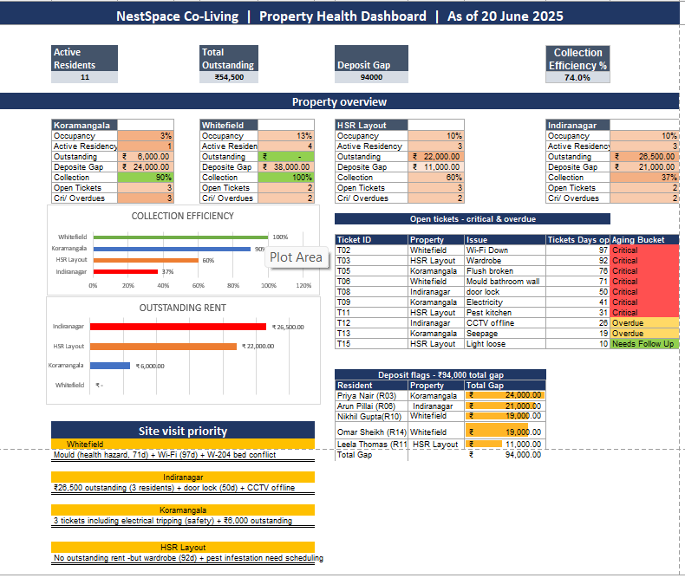

In 3-4 sentences, tell us: which property would you prioritise for your operations Manager's site visit this week, and what data led you to that recommendation?

1.Whitefield has to be the first stop this week. The mould has been sitting there for 71 days that's not just a maintenance issue, it's a health risk and the company is exposed if a resident complains.
The Wi-Fi has been down for 97 days which is frankly the longest unresolved ticket we have across all four properties. There's also a bed conflict on W-204 that needs someone physically there to sort it out, and the deposit gap of ₹38,000 is the highest of any property. One visit, four problems addressed.

2.Indiranagar is the second stop. The door lock being broken for 50 days is a security issue that needs fixing today, not next week. But beyond that, ₹26,500 outstanding across three residents tells me something is off at that property that's not bad luck, that's a pattern. A phone call won't get to the bottom of it, someone needs to go in person.

How to Submit

File | What It Should Contain
Spreadsheet (.xlsx or Google Sheets link) | Tabs: RESIDENTS (raw) | RESIDENTS_CLEAN | PAYMENTS | TICKETS | ERROR_LOG | REVENUE_SUMMARY | DASHBOARD
This document (filled in) or Your Word doc | Your written answers for all tasks

📬 Send to: Reply to the email this assignment was shared from. Subject: [Your Name] — Data Analyst Assignment. Please submit both files together.

We're rooting for you. Show us how you think!

